ＰＩＢ資料ひな形

Pre-inspection Briefing

METI CHEMICAL CO., LTD.

YY PLANT

DD MMM , 20XX

Contents:

1. Location of the Plant Site and Airport
2. Vicinity of the Plant Site and Hospitals
3. Outline of the Company and the Plant Site (As of DD MMM, 20XX)
4. Organisation of the Plant Site
5. Layout of the Administration Office
6. General Layout of the Plant Site and

Route map for the site tour

1. Health and Safety Regulations
2. Description of the Schedule 2 Chemical(s)

(Production)(XXXX)

Appendix A: List of the site representatives

Appendix B: Plant description

Appendix C: Facility description

Appendix D: Material balance

Appendix E : All handling chemical list

Appendix F : Changes after last inspection or

Declaration

1. Location of the Plant Site and Airport

 (ex. A direct distance between the plant site and POE is XXX km.)

*N*

**METI CHEMICAL CO., LTD. YY PLANT**

**(Lat. 36° 45’ 22” N, Long. 138° 32’ 02” E)**

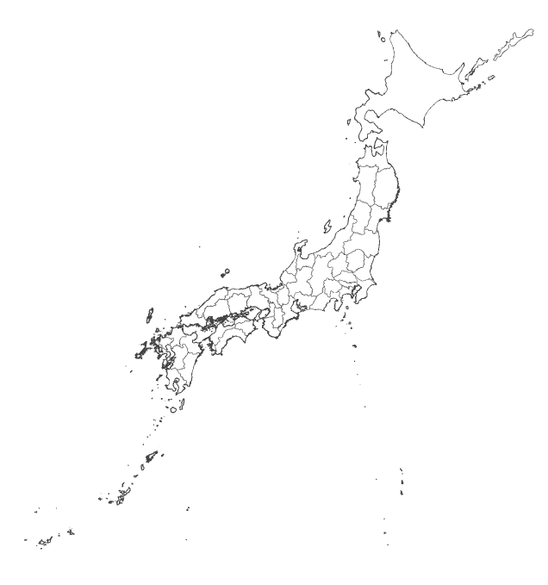

**Fukuoka Airport**

**Ｘ**

**Kansai International Airport**

**Ｘ**

**Ｘ**

**Chubu Centrair International Airport**

**Ｘ**

**Narita International Airport**

**Ｘ**

**Ｘ**

**New Chitose Airport**

出典:国土地理院ｳｪﾌﾞｻｲﾄ

Source: Geospatial Information Authority of Japan

2. Vicinity of the Plant Site and Hospitals

XX Station

**③**

Japan Railways Line

*N*

Shitetsu Line

Route 55

**METI CHEMICAL CO., LTD., YY PLANT**

AA River

XX High School

Park

**①**

XX City Hall

YY Station

**②**

XX Elementary School

XXX Expressway

XXX Bay

|  |  |  |  |
| --- | --- | --- | --- |
| **Hospital** | **Location** | **Distance** | **Required Time** |
| ABC City Hospital |  | 1.0 km | About 5 min. by car |
| DEF General Hospital |  | 1.3 km | About 7 min. by car |
| GHI Hospital |  | 1.5 km | About 8 min. by car |

3. Outline of the Company and the Plant Site (as of DD MMM, 20XX)

1. Outline of the Company

* Name of the Company:
* Address of the head office:
* Establishment:
* Capital amount (yen): ○○ yen as of DD MM, 20YY

2. Outline of the Plant Site

* Name of the Plant Site:
* Address:
* Location:
* Total area: XX ha.
* Establishment: MMM, 19XX

* Employees:
* Working time: (Production Section : )
* Accredited certifications
* Features and Main Products:

4. Organisation of the Plant Site

General Manager

Management Department

Technical Department

Manufacturing Department

General Affairs Section

Purchasing Section

Accounting Section

Quality Assurance Section

Research Section

Analysis Section

Maintenance Section

Production Section 1

Production Section 2

: Schedule 2 Chemical(s) Producing Section(s)

: Quality Control Section(s) for the Schedule 2

Chemical(s)

5. Layout of the Administration Office

Restrooms

Smoking  
Area

Clinic

Locker Room

IT Room

Meeting Room

Gentlemen

(Ladies)

Ladies

Emergency Exit

2F

Stairs

Office room

Stairs

Restrooms

Gentlemen

Conference Room

Vending Machines

Dining Hall

Ladies

1F

Emergency Exit

Stairs

Office room

Entrance Hall

6. General Layout of the Plant Site and Route map for the site tour

Shaded parts ( ) show off-limits area.

CONFIDENTIAL

Maintenance Yard



Evacuation Area

GS1 Plant

Tank Yard

QC Laboratory (2F)

Administration Building

Approximately 60 m

GS2 Plant

Administration Office (1F) /

Clinic (2F)

Utility Facilities

West Gate

AA Plant

Guard

Other

Company

Warehouse

(Product/  
Raw Material)

Incineration Facility

PY Plant

Inorganic Plant

Main Gate

AB Plant

Waste Water Treatment

Parking Space

Dot line part ( ) shows declared plants

Horizontal line part ( ) shows evacuation area.

Diagonal line part ( ) shows an area which does not belong to this plant site. (e.g. other company)

Approximately 120 m

7. Health and Safety Regulations

METI Chemical Co., Ltd., YY Plant

**1. Entry to the Plant Site**

(a) Alcoholic drinks shall not be brought on to the plant site.

(b) Anyone who is drunk shall be prohibited from entering the plant site.

(c) Dangerous equipment or substances shall not be brought on to the plant site.

(d) The Inspection Team shall be escorted by representative(s) of the Inspected State Party, when it enters or leaves the plant site.

**2. Administration Office**

(a) The Inspected State Party will indicate the areas that are available to the Inspection Team in the pre-inspection briefing. Access to other parts of the office is subject to the approval of the Inspected State Party.

(b) Smoking is permitted only in the designated areas.

(c) Use of fire or electricity without permission is prohibited.

**3. Plant Area**

(a) Bringing ignition sources and hazardous materials into the plant area is prohibited.

(b) Use of fire or electricity without permission is prohibited.

(c) Access to the plant by the Inspection Team is allowed in the presence of the representative(s) of the Inspected State Party, and the Inspection Team shall follow the directions of the plant site personnel.

(d) The Inspection Team shall not operate and/or touch any equipment instruments, raw materials or products belonging to the plant site in any area of the plant.

(e) Use of equipment that generates electricity (static) or sparks in the plant area is restricted to the explosion-proof type. If the Inspection Team deems it necessary to use such equipment, its use shall be subject to the approval of the Inspected State Party. Use of mobile phone is prohibited in the plant area.

(f) In general, entering the following area is prohibited:

1) Where there are suggestions of, or signs indicating, “Danger” or “No Entry”.

2) Where heavy-load machines are in operation.

3) Where welding operations using gas or electricity are taking place.

4) Where equipment is being dismantled.

5) Where equipment is being operated.

6) Where construction is under way.

7) Inside of apparatuses or pits.

If the Inspection Team deems it necessary to inspect any of the above-mentioned areas, such inspection is subject to negotiations between the Inspected State Party and the Inspection Team.

**4. Medical Assistance**

To facilitate medical assistance to be provided by the Inspected State Party, the Inspection Team leader shall inform the Inspected State Party of the kind and extent of the medical care needed by the sick or injured Inspection Team member. The Inspected State Party will provide the requested medical care to the extent possible.

**5. Evacuation Procedures**

The Inspection Team shall obey the directions of the plant site personnel. The designated evacuation point will be indicated in the pre-inspection briefing.

Date:

Signature:

8. Description of the Schedule 2 Chemical

CONFIDENTIAL

Production (XXXX)

IUPAC Chemical Name: (CASRN: )

Common/Trade Name :

1. Reaction Formula

2. Process Description

3. Block flowchart of the Production

4. Purpose of the Schedule 2 chemical production

5. Declared Plant(s) Description

6. Production Capacity

Appendix A: List of the site representatives

|  |  |
| --- | --- |
| Name | Title |
|  |  |
|  |  |
|  |  |
|  |  |
|  |  |
|  |  |
|  |  |